### Department of Computer Science and Engineering

### School of Engineering and Technology

May 2023

## Mathematics for Engineers - II

**Project Report**

**(MTH1711)**

***Heart Disease Analysis***

***Group Members:***

*Vedansh kumawat*

*220489*

*Anusha Singh*

*220641  
Shivanshi Goel   
220457*

## ACKNOWLEDGEMENT

First and foremost, we are very much thankful to our lecturer Dr. Ranjib Banerjee for his guidance, encouragement, help and useful suggestions throughout the completion of the project. His untiring and painstaking efforts, individual help made it possible for our group to complete this work on time. We are glad that we got an opportunity to know more things about the concepts. We would like to appreciate ourselves for the cooperation, team spirit we had. We would also like to appreciate the technology which made our work simpler and easier. We would like to appreciate the web, resources, and our textbook where we got sufficient information to complete our project.

## CONTENTS

Abstract 1

Introduction 2

Problem Statement 3

Data 4

Pre-processing of Data 6

Descriptive Statistics and Visualizations 10

Hypothesis Testing 15

Conclusions 23

References 24

# ABSTRACT

Heart disease kills millions of people worldwide and is the leading cause of death for both men and women. According to WHO, cardiovascular disease is the leading cause of death worldwide, with an estimated 17.9 million people dying from it, with heart attacks and stroke accounting for 85% of deaths. Numerous health factors, such as inherited blood disorders, resting heart rate, cholesterol, and others, all contribute to the prediction of a heart.

Heart disease kills millions of people worldwide and is the leading cause of death for both men and women. According to WHO, cardiovascular disease is the leading cause of death worldwide, with an estimated 17.9 million people dying from it, with heart attacks and stroke accounting for 85% of deaths. Numerous health factors, such as inherited blood disorders, resting heart rate, cholesterol, and others, all contribute to the prediction of a heart attack.

# INTRODUCTION

The heart is one of our bodies' most important organs. Heart disease, also known as cardiac disease, is a form of heart dysfunction.

A variety of factors can increase one's risk of developing heart disease. While some of these factors are beyond our control, many can be avoided by living a healthy lifestyle. Uncontrollable factors include gender, age, family history, and heart shape. High blood pressure, high cholesterol, obesity, smoking, and diabetes are all preventable risk factors.

In the United States, heart disease is the leading cause of death. Every 36 seconds, someone in the United States dies from cardiovascular disease. Heart disease kills approximately 655,000 Americans each year, accounting for one out of every four deaths. In this research. In this analysis, we will use a heart disease dataset to investigate the most important factors that contribute to heart disease.

# PROBLEM STATEMENT

* Do men or women have a higher risk of having a heart attack? When is the most common age for a heart attack? The comparison of gender and age in this study will explain the likelihood of a heart attack.
* In this study, the male and female ages, gender, and target variable are used. Following the presentation of the summary statistics for male and female, a histogram and bar plot are plotted to present the data in a more comprehensive manner.
* A Chi square test of association between gender and risk of heart attack is also used to determine whether there is an association between gender and risk of heart attack. Following the testing of assumptions, two sample t-tests are used to determine whether there is a difference in the mean age of male and female patients with a high risk of heart attack.
* This investigation has established and tested the following hypotheses:
* There is a link between gender and an individual's risk of having a heart attack.
* The age of males and females who are at high risk of having a heart attack.

# DATA

* The dataset used contains 14 variables and 303 observations of various individuals from the United States of America, Cleveland. The dataset used in this task was generated from:

[https://www.kaggle.com/madhav000/attack-prediction-accuracy-morethan-80.](https://www.kaggle.com/madhav000/attack-prediction-accuracy-more-than-80)

* The observation of the data was drawn from:

[https://archive.ics.uci.edu/ml/datasets/Heart+Disease.](https://archive.ics.uci.edu/ml/datasets/Heart+Disease) The dataset contains 76 variables from different countries such as Hungary and Switzerland but have been subset for easier analysis and the Cleveland database is the one that has been selected for this task.

* Age: Age of individual in years.
* Sex: Gender of the individual. 0 for Female and 1 for Male. Sex variable has been renamed to Gender.
* cp: Chest pain type from 1 to 4. Does not have any levels.
* trestbps: Resting blood pressure. (in mm Hg on admission to the hospital)
* Chol: Serum cholesterol measured in mg/dl.
* fbs: Fasting blood > 120 mg/dl. 0 for False, 1 for True.
* restecg: Resting electrocardiographic results. 0 for normal, 1 for having abnormality, and 2 for probable or definite hypertrophy.
* thalach: Maximum heart rate achieved measured in beats per minutes.
* exang: Exercise induced angina. 0 for False, 1 for True.
* oldpeak: ST depression induced by exercise relative to rest. Does not have any levels.
* slope: Slope of peak exercise ST segment. 1 for upsloping, 2 for flat, 3 for downsloping.
* thal: Thalassemia a inherited blood disorder, 0 for normal, 1 for fixed defect and 2 for reversable defect.
* target: Likelihood of heart attack. 0 for less chance of heart attack and 1 for more chance of heart attack.

# PREPROCESSING OF DATA

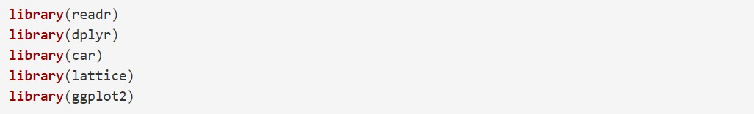

• Read_csv is used to import the file, and factor is used to order the sex and target variables. Furthermore, the sex variable has been renamed gender.

• The summary statistics of the age of the individuals in this study, broken down by male and female, are shown below. The summarise function generates a new data frame with the minimum, median, maximum, and mean age, first and third quartile, standard deviation, number of observations, and missing observations.

heart <- read_csv("heart.csv")

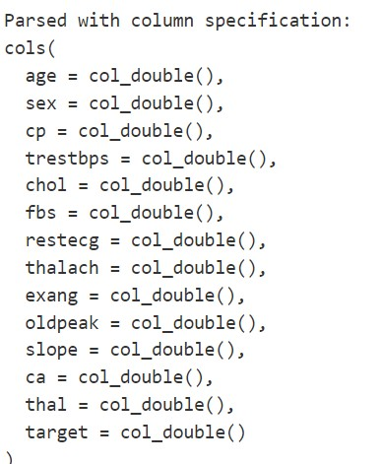

str(heart)

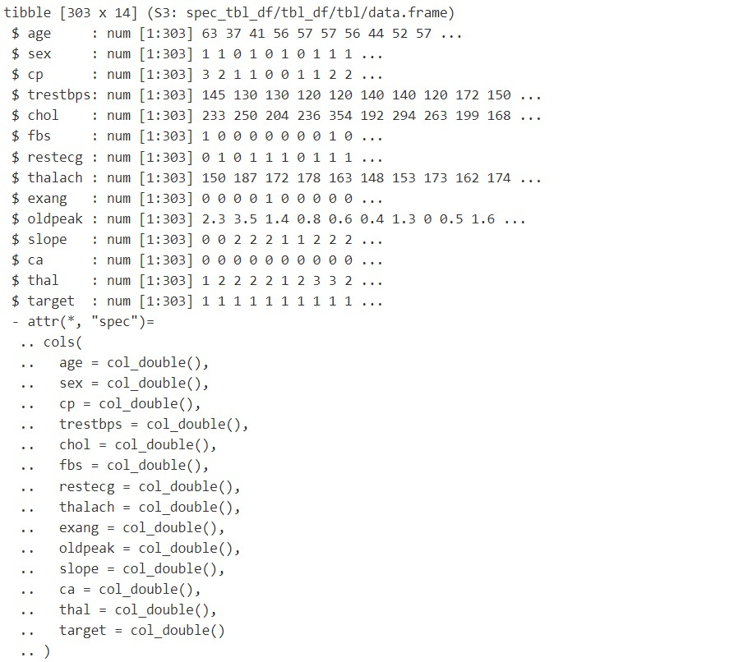

summary(heart)

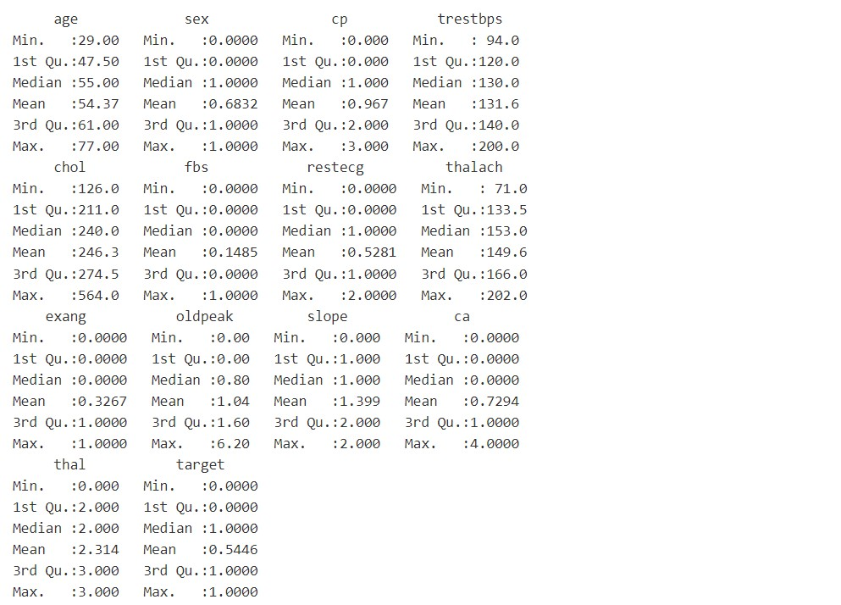

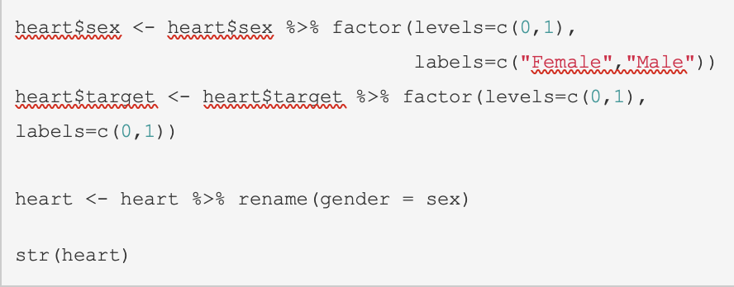

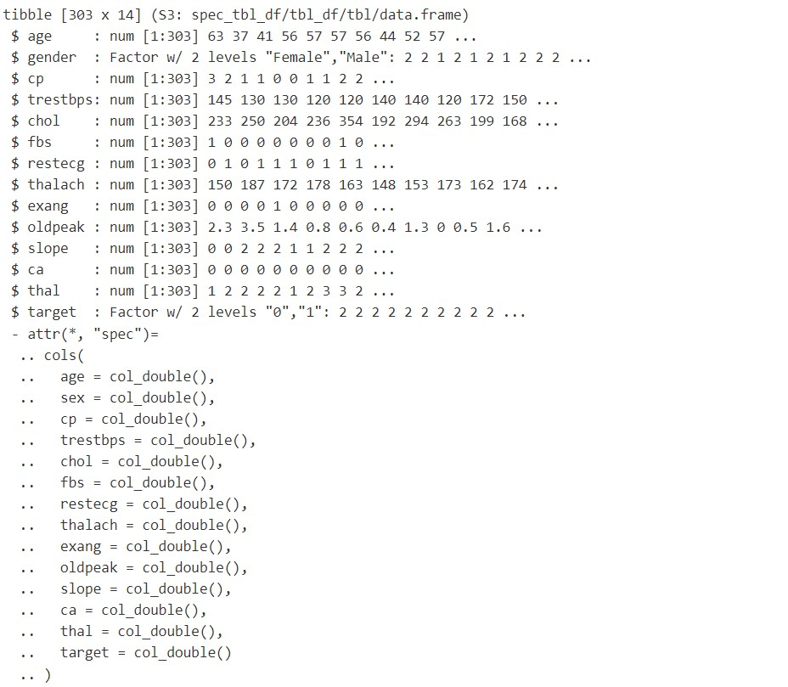



heart_summary1

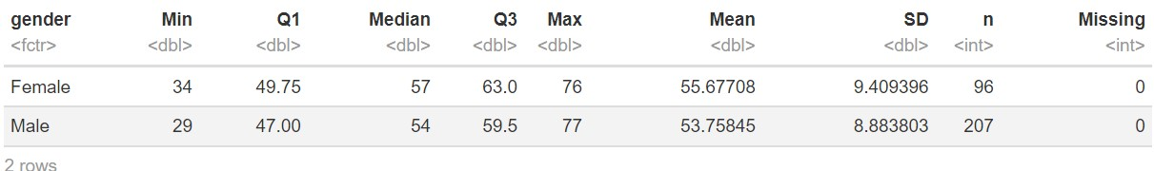

# DESCRIPTIVE STATISTICS AND VISUALISATION

• The male and female mean ages are very close, with the male age being 53.76 and the female age being 55.68.

• Female has a higher standard deviation and a higher standard error than male. • Based on the histogram, female appears to have a higher likelihood of a heart attack because the proportion is much larger than male, whose likelihood of a heart attack appears to be fairly close.



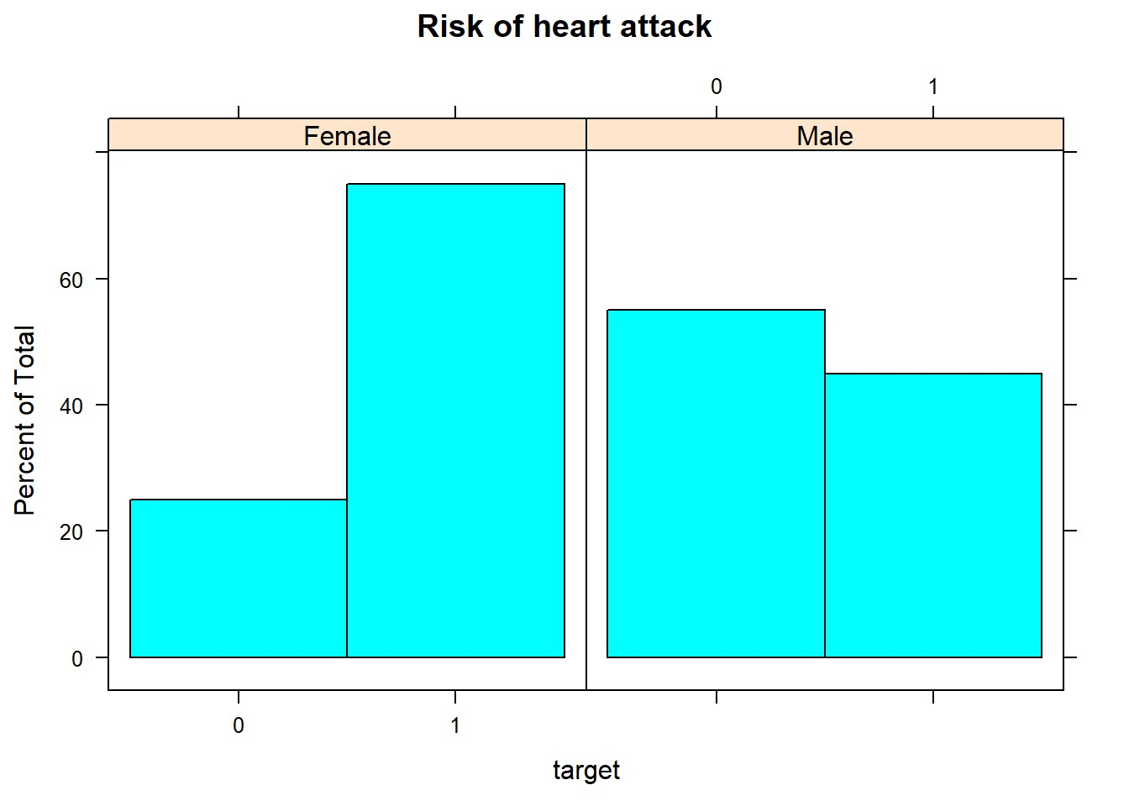

* In terms of the age of individuals, the Female sample appears to have the highest percent of total in the age range of 55 to 60 years followed by 50 to 55 years. While the Male sample appears to have the highest percent of total in the age range of 60 to 65 years.



* The plot below shows the distribution in the ages of the individual in this investigation. The curve appears to be more negatively skewed.



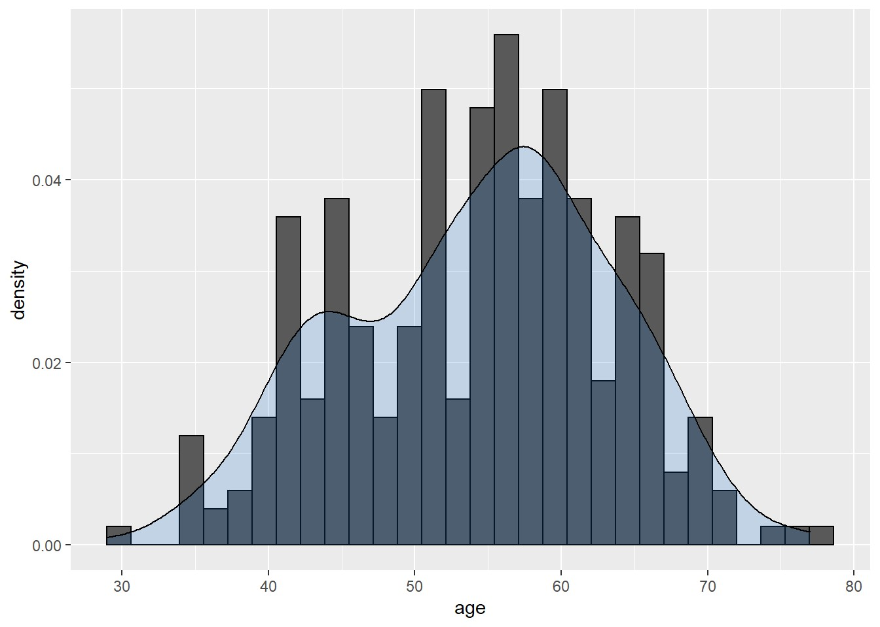

• The heart dataset is filtered for people who are at high risk of having a heart attack.The plot below compares the ages of these individuals by displaying the barplot side by side. By observing, we can see that the Male has a greater number of observations of ages than the Female. Observing the plot, however, is inconclusive as to whether Male and Female have the same age of a high likelihood of a heart attack.

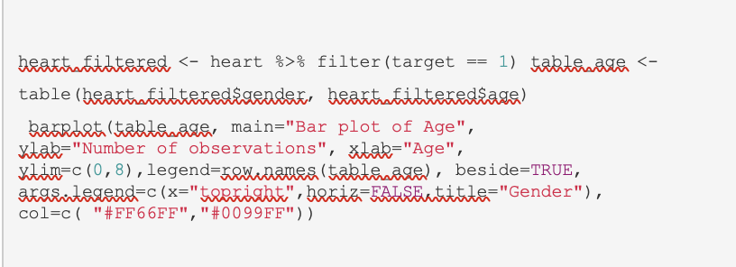

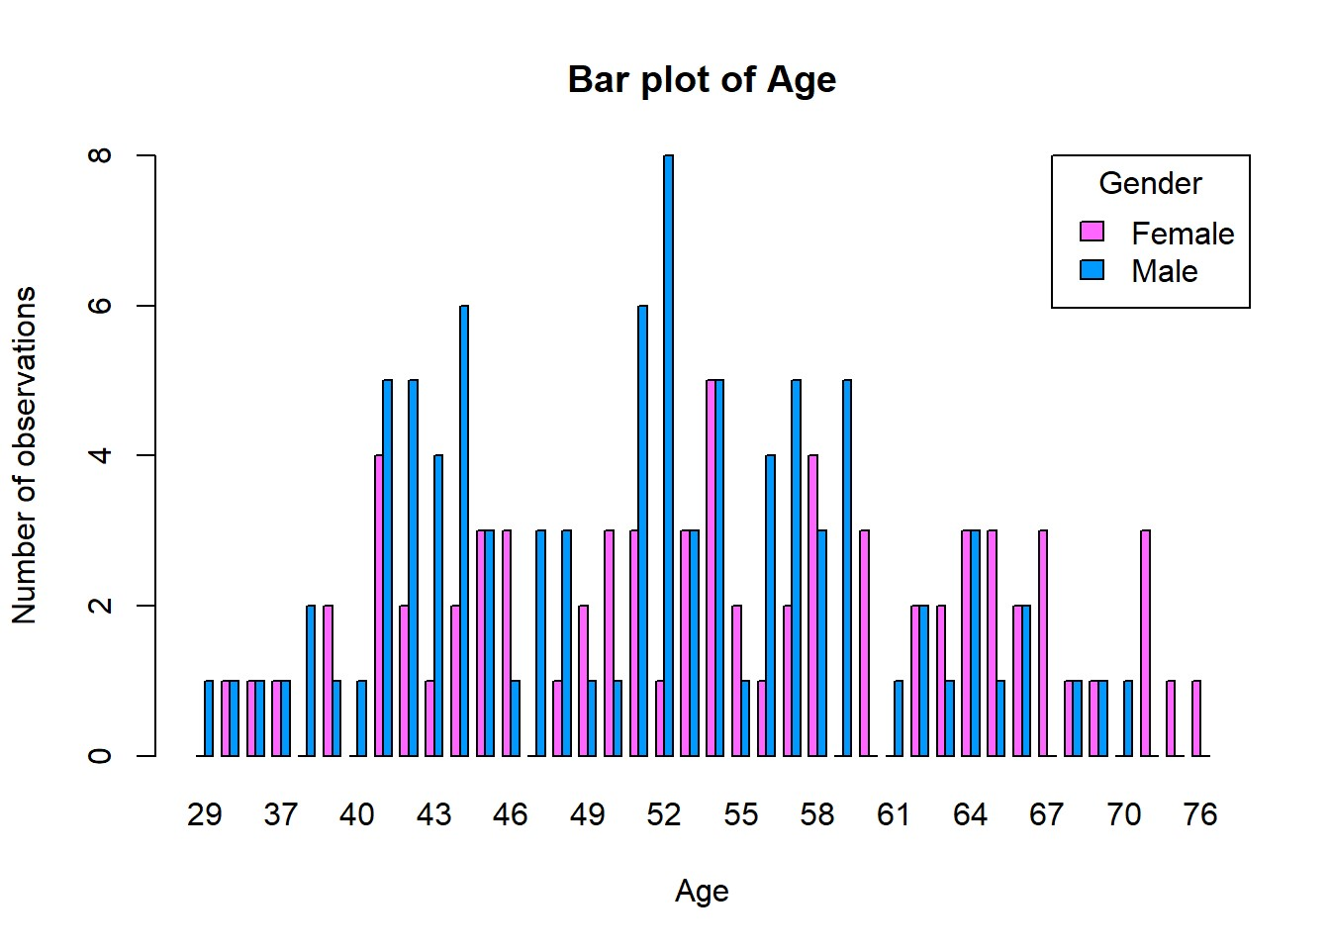

• The boxplot demonstrates that there are no outliers in the data that must be addressed. The Female has a larger interquartile range than the Male, indicating that there is more variation in age. According to the summary statistics, females have a higher mean age of 54.56 than males, who have a mean age of 50.90. Furthermore, Female has a higher standard deviation of 10.27 than Male, which is 8.68.



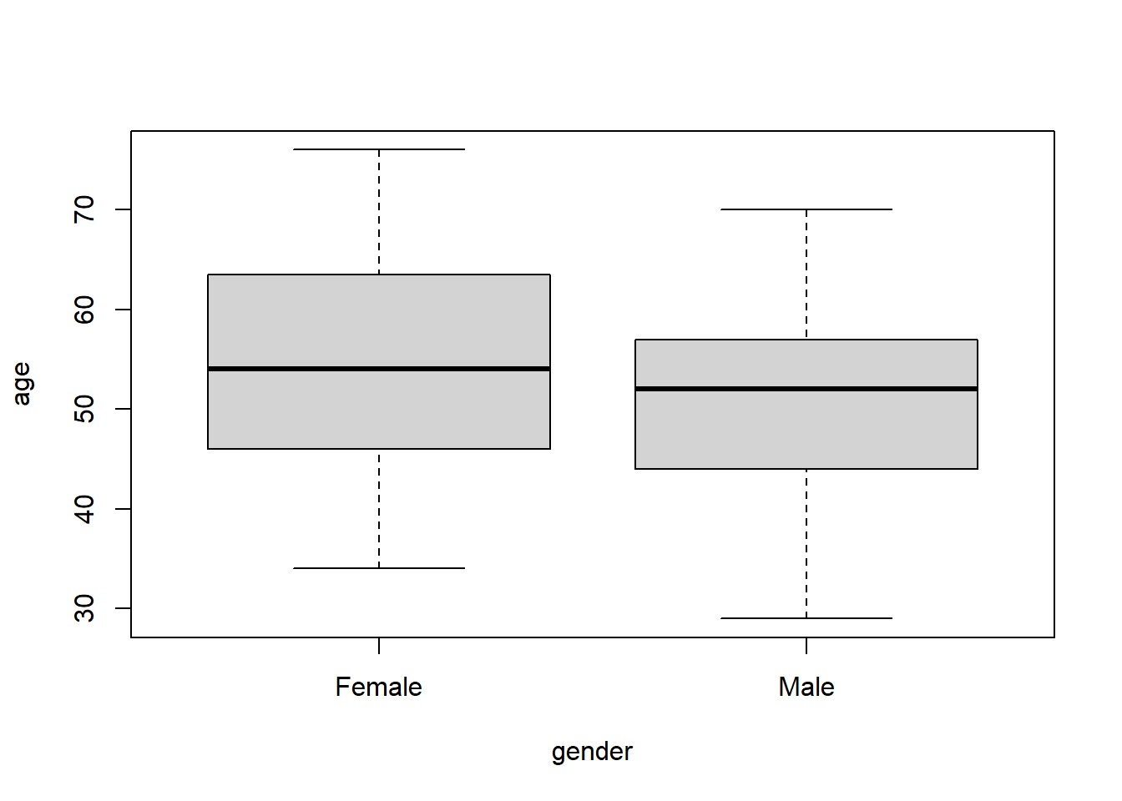

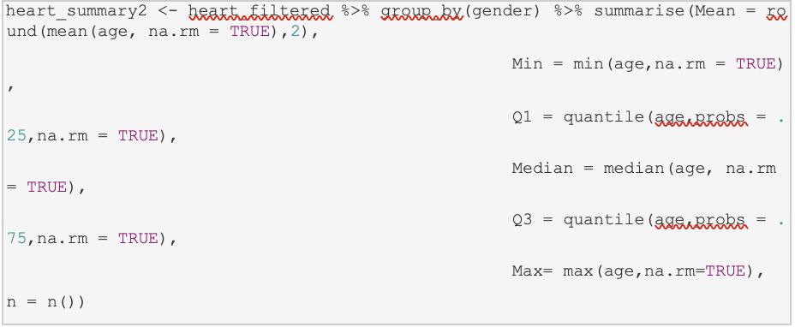



heart_summary2

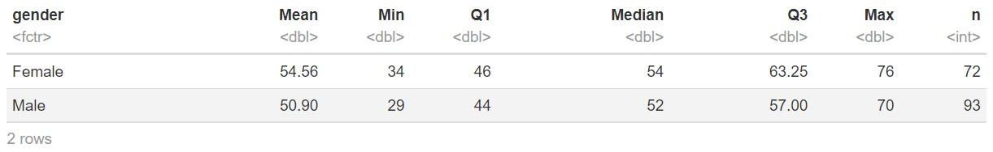



heart_summary3

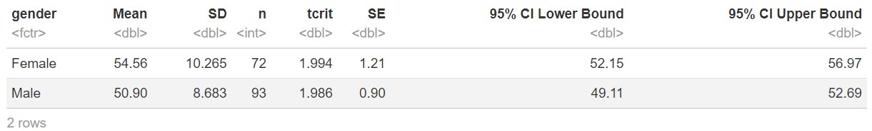

# HYPOTHESIS TESTING

## Chi square test of association

• Specify the null and alternate hypotheses.

• H0: Probability that a heart attack and gender are related.

• H1: It is unlikely that a heart attack and gender are related.

• It is assumed that no more than 25% of expected counts are less than 5 and that all individual counts are 1 or greater.

• Table_heart2 shows that males have a 0.44 chance of having a heart attack, while females have a 0.75 chance of having a heart attack.

table_heart <- table(heart$target, heart$gender) table_heart

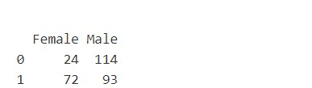

table_heart %>% addmargins()

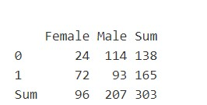

table_heart2 <- table_heart %>% prop.table(margin=2) table_heart2

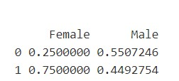

• The chi-square test of association for gender and risk of heart attack yields a p-value of 1.877e-06, which is less than 0.001. As a result, H0 is rejected as the null hypothesis, and the chi-square test of association is statistically significant. The findings indicate that there is no evidence of a link between a person's gender and their risk of having a heart attack. As a result, the likelihood of having a heart attack is determined by the individual's gender.

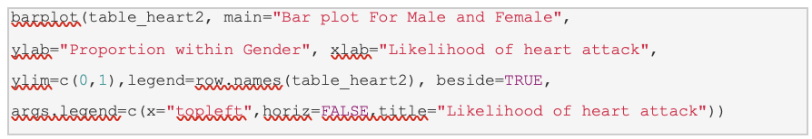

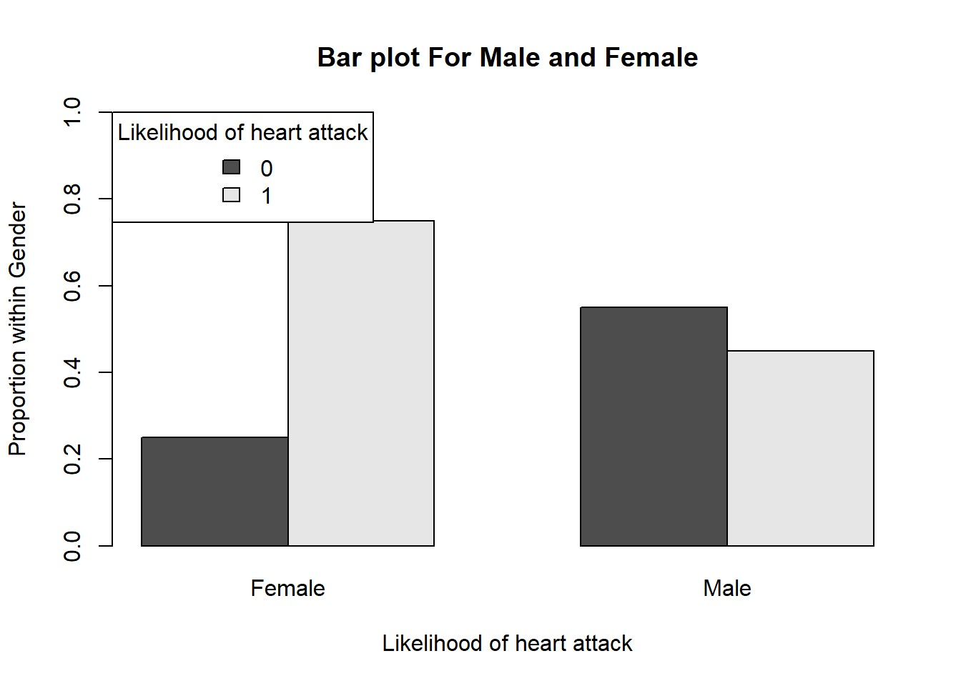

chi_heart <- chisq.test(table_heart, p=c(0.5,0.5)) chi_heart

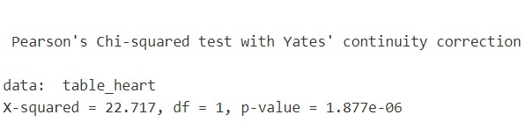

chi_heart$expected

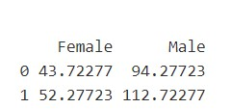

chi_heart$observed

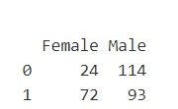

## Two sample t test

* The next test used will be to understand is there statistical difference in the age of Male and Female of which have a higher chance of heart attack.
* The heart dataset is filtered for individuals who have a high likelihood of heart attack.

heart_filtered <- heart %>% filter(target == 1)

## Student T Test

## 

|  |
| --- |
| • The t test is used to compare the difference in mean age between the male and female populations. The two sample t tests assume that the populations being compared are independent of one another, and that the data for both the male and female populations are normally distributed and have equal variance. As previously stated, the following assumptions have been verified.  • H0: M1 - M2 = 0  • HA: M1 - M2 =/= 0, where M1 and M2 are the male and female mean ages, respectively. |

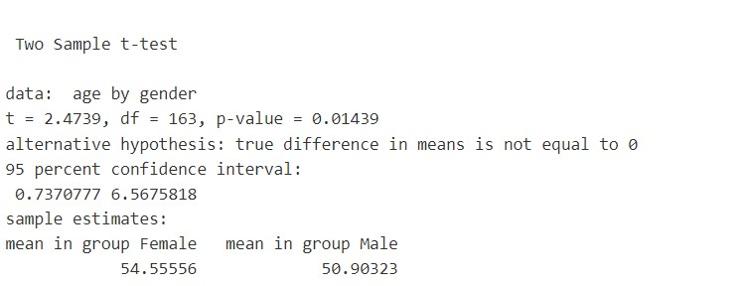

result$conf.int

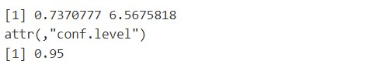

result$p.value



• The two sample t test revealed a statistically significant difference in the mean age of male and female patients with a high risk of heart attack. We reject the H0 because p value = 0.014 0.05 and the 95% CI of the estimated population difference [6.57,0.74] does not capture the H0: M1 - M2=0. As a result, the two sample t test was statistically significant, and we can conclude that the age of heart disease in men differs significantly from that in women.

## CONCLUSION

* The first analysis was based on a categorical association to see if gender influences the likelihood of having a heart attack. Based on the visualisation, there appears to be evidence that the female gender is at a higher risk of heart attack, but the chi square yields a different result.
* The chi square test of association between gender and likelihood is statistically significant, implying that a person's gender is unrelated to their risk of having a heart attack. As a result, whether a person has a high or low risk of having a heart attack has nothing to do with their gender.
* The second study sought to determine whether male and female people of the same age have the same risk of having a heart attack. When the QQ plot was examined, the mean age for both the Male and Female showed evidence of normalcy.
* The central limit theorem also establishes that the mean distribution of more than 30 samples will converge to normality. As a result of the large sample size in both groups, the t test can be used. The Levene test of variance homogeneity was used to determine whether the variance of male and female ages is equal. We can conclude that the population variance is homogeneous based on the p value of 0.09.
* As a result of testing both assumptions of the t test above, we can conclude that there is normality and equal variance. The t test is used to identify people who are at high risk of having a heart attack. The t test results show that there is a difference in the mean age of Male and Female. Finally, the average age of men and women who are at high risk of having a heart attack differs.
* At a stricter confidence interval of 0.01, however, the p value of 0.014 is greater than 0.01 and the null hypothesis is not rejected, implying that the mean age of Male and Female is the same.

# REFERENCES

* World Health Organization 2017, *Cardiovascular disease (CVDs)* Webpage (HTML Format), World Health Organization, Melbourne,

[https://www.who.int/en/news-room/fact-sheets/detail/cardiovasculardiseases-(cvds)](https://www.who.int/en/news-room/fact-sheets/detail/cardiovascular-diseases-(cvds))

* [https://www.who.int/news-room/fact-sheets/detail/the-top-10-causes-ofdeath](https://www.who.int/news-room/fact-sheets/detail/the-top-10-causes-of-death)

* <https://www.cdc.gov/heartdisease/facts.htm>

* [https://news.mit.edu/2019/machine-learning-shows-no-difference-anginasymptoms-between-men-and-women-1106](https://news.mit.edu/2019/machine-learning-shows-no-difference-angina-symptoms-between-men-and-women-1106)